

**Water - contaminants and levels**

**Stakeholders: Koru Impact Solutions, customers (B2B fund managers), regulatory bodies (FCA, SRI), competitors, potential investors, public**

**Client Details**

|  |  |  |  |
| --- | --- | --- | --- |
| **Name** | **Email** | **Phone** | **Preferred Contact Method** |
| **Kate Barnard** | **kate@koruimpactsolutions.com** | **07961847528** | **email** |

**Module Leader Details**

|  |  |  |  |
| --- | --- | --- | --- |
| **Name** | **Email** | **Phone** | **Preferred Contact Method** |
| **Salma Chahed** | **S.Chahed@westminster.ac.uk** |  | **email** |

**Team Details**

|  |  |  |  |
| --- | --- | --- | --- |
| **Name** | **Email** | **Phone** | **Role/Responsibilities** |
| **Laurita Kunickaite** | **w1947567@my.westminster.ac.uk** | **07384707050** | **Project manager:**  **Create and keep a clear project plan of action**  **Organizing and minute team meetings, providing the plan for the meetings**  **Provide updates to the client on the team’s progress**  **Provide insights and recommendations in a report for business executives** |
| **Om Sadigale** | **w1943544@my.westminster.ac.uk** | **+919076249855** | **Data auditor:**  **Identify inherent risks or biases of data set affecting its accuracy**  **Ensure reliability of data source by means such as interrogating data collection process** |
| **Yahya Habib** | **w1948192@my.westminster.ac.uk** | **+447497062433** | **Developer of statistical model:**  **Creation of statistical model to measure the margins of error against key metrics**  **Assist the data auditor in Improving quality of sourced data** |
| **Anas Kagigi** | **w1914597@my.westminster.ac.uk** | **+447576801893** | **Data researcher:**  **Research additional data resources to contribute and create more wholistic data set to improve data accuracy** |
| **Faisal Qaderi** | **w1897498@my.westminster.ac.uk** | **+447383337940** | **Python programmer:**  **Cleaning and transforming data for analysis using Python**  **Visualise the data that have been cleansed for further analysis**  **Advised on decision-making process, using Python data mentioned above** |
| **Ayaan Iqbal** | **w1948385@my.westminster.ac.uk** | **+447709804137** | **Implementer:**  **Inputs the analysed data and reviews against the key lenses of health, society, environment and carbon intensity** |

**Project Background**

Koru Impact Solutions is a revolutionizing organization with its AI-driven platform, which allows companies to partner with impactful projects worldwide that align with their strategic investments and sustainability goals. The company aims to replace the laborious process of producing impact reports with an automated digital solution, leveraging APIs and data sets, to generate enhanced reports for fund managers. Reports are being directed by regulatory bodies such as the Financial Conduct Authority (FCA) and Socially Responsible Investing (SRI) frameworks.

The challenge is ensuring the accuracy, reliability and consistency of the data used in creating those reports. Moreover, expanding the process of reporting meaningful insights into the environmental and sustainability impacts of investment portfolios.

**Project Description**

The project goal is to address the pollution issue of water contaminants and their levels and create an impact report for fund managers. Koru Impact Solutions addresses the significance of water quality as a key environmental metric affecting humans’ health and ecosystem integrity.

Objectives of this project include integrating the provided data set, applying the created statistical model and providing insights and recommendations for the client. The main aim is to highlight the increasing importance of environmental, social and governance (ESG) considerations in investments. Also, a broader understanding of water contamination risks.

Overall, by bringing attention to water pollution and its causes in the report, the project aims to encourage fund managers to make informative decisions supporting sustainable water management, contributing to environmental stewardship goals.

**Project Importance**

Conducting this project is crucially important for Koru Impact Solutions as it meets the company’s aim to automate impact reports and promote sustainable investing practices to its customers. By creating a digital auditing system focusing in this case – water contaminants, the organization expands its position as a leader in the ESG space. This project helps the company to stand out from competitors by offering quicker and more innovative solutions that fulfil the needs of B2B clients and fund managers.

Moreover, Koru Impact Solutions demonstrates its determination to environmental and social responsibility. The successful implementation of this project not only strengthens the organization’s market position but also promotes transparency, accountability and positive environmental outcomes in the financial sector. Ultimately, the company by prioritizing this project solidifies its reputation as a trusted partner and provides meaningful impact in the industry.

**Project Scope**

|  |  |  |  |
| --- | --- | --- | --- |
| **Project deliverables** | **Project Outcomes** | **Key activities to achieve the outcome** | **Activity lead** |
| **Comprehensive data evaluation report** | **Understanding of water contaminant issue and identification of biases of data** | 1. Identify inherent risks or biases of the data set 2. Conduct the reliability of the data source 3. Identify key trends and patterns of concern related to water contaminants 4. Document findings and recommendations | Om Sadigale |
| **Pre-processed and integrated data sets** | **1. Cleaning and integrating data for global analysis** | * 1. Cleaning and transforming data   2. Standardize data formats and units   3. Aggregate data to the global level | Faisal Qaderi, Yahya Habib |
|  | **2. Implement a statistical model for error margin measurement** | * 1. Select the appropriate statistical model for measuring the error margins   2. Use algorithms and formulas to calculate error margins based on data precision, geographic variability, and other relevant factors.   3. Test and validate the statistical model   4. Improve and optimize the model based on testing results and improve accuracy and reliability. | Faisal Qaderi,  Yahya Habib |
| **Additional data set integration and aggregated outputs analysis report** | **1. Integrate diverse data sources for improvement of the accuracy of the metric** | * 1. Find relevant data sources/ literature   2. Assess the quality and relevance of new data sets   3. Aggregate new data with existing data for analysis   4. Analyse the impact of the integration on error margins | Anas Kagigi,  Ayaan Iqbal |
|  | **2. Assess the impact of water contaminants** | 2.1. Apply results through health, society,  environment, and carbon intensity lenses  2.2. Assess impact on each field  2.3. Summarize key findings and trends | Ayaan Iqbal,  Anas Kagigi |
| **Insights and recommendations report** | **Provide key insights and recommendations based on analysis** | 1. Summarize key findings from the analysis 2. Provide actionable insights and recommendations 3. Combining created reports and presentations | Laurita Kunickaite |
| **Resources required** | | Provided data set and additional data sets, project plan, interview with a stakeholder, advanced analytical tools (Python), data storage (Github), timeline planning software (Gantt), human resources (students in this project), sufficient time, communication tools (WhatsApp, email), collaboration with module leader | |
| **Project Constraints** | | Tight project timelines, lack/availability of high-quality additional data sources, lack of experience in statistical models, environmental science and project management, | |
| **Risks** | | 1. **Data quality and availability:**    1. Proceed thorough data validation    2. Implement data cleaning and processing techniques to ensure accuracy of data    3. Collaborate with reliable data providers 2. **Technical skills:**    1. Ensure regular communication with team members and raise concerns    2. Have contingency plan for troubleshooting    3. Seek additional information online 3. **Experience:**    1. Identify and address skill gaps within team and work as a team to fill the gap    2. Prioritize tasks based on team members skills 4. **Stakeholder management:**    1. Establish clear channels of communication with stakeholders    2. Provide regular updates and progress reports    3. Address stakeholder concerns promptly    4. Ensure collaborative and transparent project environment 5. **Timeline delays:**    1. Develop a realistic project timeline    2. Regularly monitor project progress    3. Identify and address issues early    4. Adjust timeline as needed 6. **Project scope:**    1. Identify clear project objectives and boundaries    2. Regularly review and prioritize project tasks    3. Gain stakeholders’ approval for any changes | |

**Timeline**

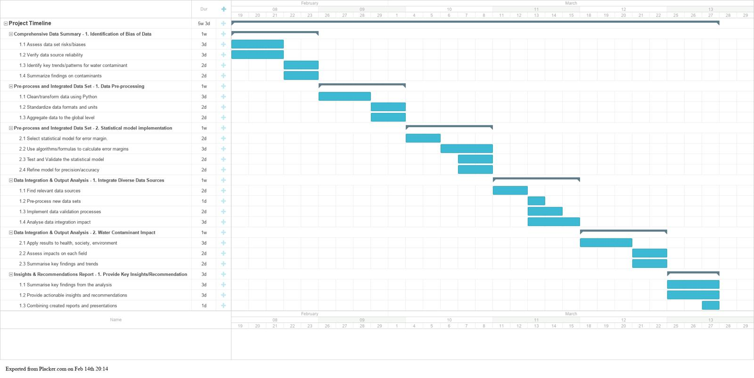

**Meeting Dates/Times/Venues**

|  |
| --- |
| **Proposed Team Meetings**: |
| Week 1: Orientation- initial team meeting (06/02/24 21:00 -Zoom  07/02/24 21:00 – Zoom) |
| Week 2: Project Briefing with Industry Client (11/02/24 20:00 - Zoom  13/02/24 21:00 – Zoom) |
| Week 3: Data preparation, analysis & initial recommendations (18/02/24 21:00 - Zoom  20/02/24 21:00 – Zoom) |
| Week 4: Data analysis & initial recommendations (25/02/24, 21:00 - Zoom  27/02/24 21:00 – Zoom) |
| Week 5: Bringing together project draft report (03/03/24, 21:00 - Zoom  05/03/24 21:00 - Zoom) |
| Week 6: Draft report (10/03/24, 21:00 - Zoom  12/03/24 21:00 – Zoom) |
| Week 7: Preparing your final report & presentation (17/03/24, 21:00 - Zoom  19/03/24 21:00 –Zoom) |
| Week 8: Live presentation & final report submission (24/03/26, 21:00 - Zoom  26/03/24, 21:00 – Zoom) |